Andrew Stiles
CSD-430
Prof. Ostrowski
Assignment 8 – Project Part 4
10/12/2025

Index.jsp updated
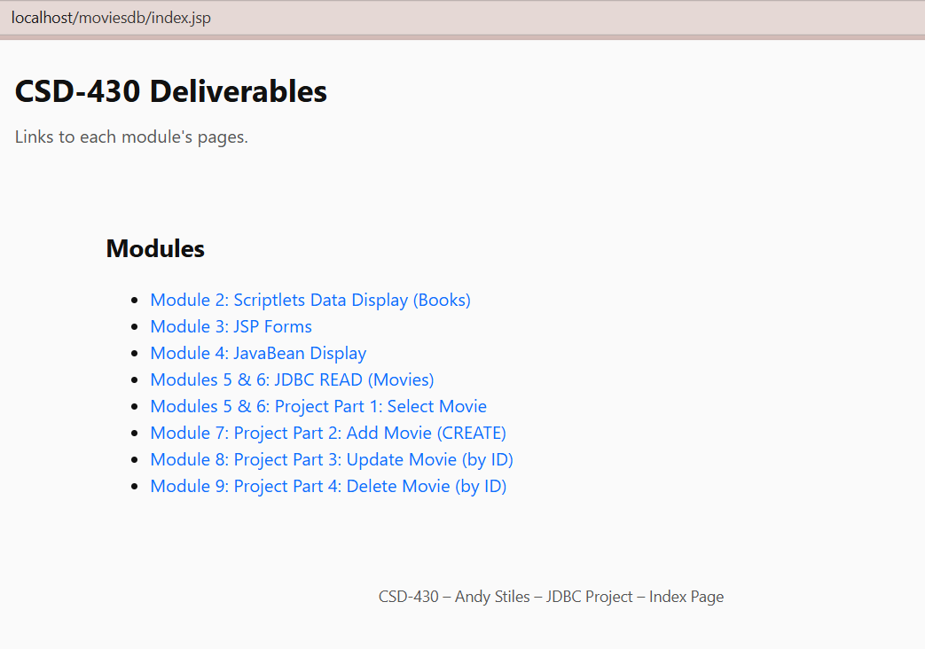

deleteList.jsp
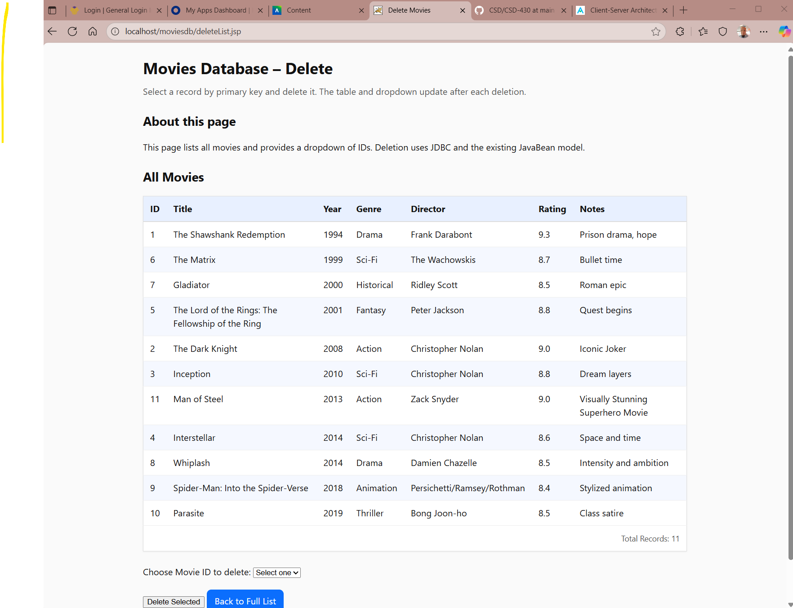

deleteProcess.jsp (ID 11 is deleted)
